Task

You have been tasked with constructing a Learning Station on the basic operating system commands for the Linux platform. The shape of your Learning Stations solves a challenging problem on Bandit at OverTheWire (OTW).

## Your learning station must include at the minimum:

* Evidence you solved up to bandit10 for year 11 students and 15 for year 12 students who've done the previous 10 before. Note: if you have done more than 15 last year, do five more than where you were at. 😊
* Material for learning stations that covers more than one of the following commands (you'll likely need to do an exercise from bandit 6+):
  + file
  + find
  + du
  + grep
  + sort
  + uniq
  + strings
  + base64
* Note, you are not writing man articles on the commands. Instead, you are teaching someone how to solve a bandit problem that may require multiple commands.

## Learning Stations

What is a learning station? In education, Learning Stations are points of interest in a classroom that provides learners with the opportunity to step through a problem, teaching them to identify the different steps and highlighting how to solve them.

Our version of Learning Stations will consist of [markdown documents](https://www.markdownguide.org/cheat-sheet/) and potentially additional elements needed to teach, inform, or explain the scenario. Markdown Documents are similar to web pages but come with a lightweight formatting guide. Check the cheat sheet above or the style guide below for more information.

Use the template markdown provided with this assignment to help frame your work. Also, look at the cookbook articles on our GitHub for examples of how things have been broken down.

Remember, the goal of the process is not to show them the commands they need to solve the problem but to inform or educate them on how they could replicate, why they might care, etc.

In essence, you must provide a

* Introduction to the problem being solved
* An explanation of the solution
* An explanation of the different commands and how they work
* (extension) An analysis/evaluation/comparison of different commands may also solve the problem.
* Feel free to add other material that you feel is essential to your learning station

### Learning Stations vs Cookbooks Recipes

In my classes, I create many Recipes for students to follow. Learning Stations are similar to recipes. However, a recipe is intended to be supported by lectures/direct teacher support. They can also focus on people with deep technical literacy learning a new skill.

An example of a technical recipe can be seen here:

|  |
| --- |
| Configuring the router via TFTPProblem: You want to load configuration commands via TFTP. Solution: You can use the copy TFTP: command to configure the router via the Trivial File Transfer Protocol (TFTP)  Text  Description automatically generated Discussion: Generally, most people configure their routers using telnet/ssh and the configured terminal command. However, people tend to resort to cutting and pasting a large set of commands for significant configuration changes. While this method works, it is inefficient and slow, particularly if you have to configure many routers.  Using TFTP to download a large set of configuration commands, the router doesn't need to echo each character to your screen, reducing the overhead and increasing the interaction speed.  In this example, the router is configured by downloading a file called NEWCONFIG from a server at 192.168.10.1 using the Trivial File Transfer Protocol (TFTP). The router will copy the entire file by TFTP before entering the commands into the running configuration.  Using TFTP is helpful because sometimes, some commands in the middle of a configuration could disrupt your access to the router, but the rest of the commands might fix the problem. If you tried to enter them manually using telnet/ssh and configure the terminal, you could lock yourself out of the router. A typical example of this problem happens when you replace an active access list. When you enter the first line, the router puts an implicit deny-all at the end, which can break your session. Using TFTP avoids this problem. |

You can see how the author of this recipe broke their response into multiple chunks.

### Explanation:

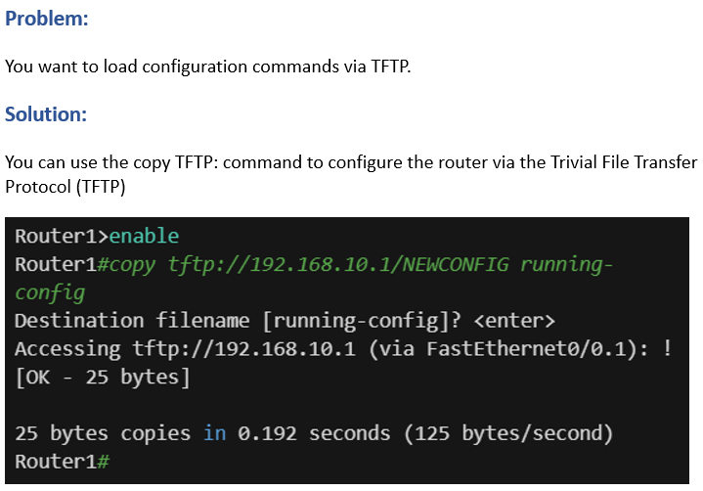

Explanation of the problem and the solution

In the example above, the author explains the problem and the solution. In both cases, it is very superficial and intended to draw a reader's attention to a specific problem.

### Analysis:

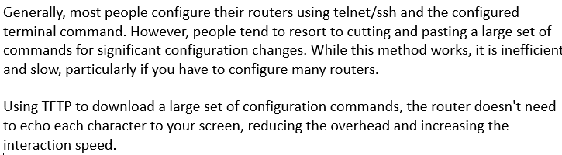

An analysis of the problem and solution

Next, the author details the underlying problem (copy and pasting) that needs to be addressed. This form of analysis highlights to the reader why they should consider the alternative presented in this recipe.

### Evaluation:

Explanation and evaluation

Finally, the author goes through and explains the solution and then evaluates the default solution against the new solution.

## The difference between recipes and learning stations

Notice how the recipe above has many assumptions? We assume that the reader knows that TFTP exists, that they understand terminology like active access lists, what deny-all is, or even what sessions are. These elements were controlled (more or less) by being in a structured classroom environment: lectures, worksheets, prior experience, and scaffolded learning supplement recipes.

Learning Stations, however, make fewer assumptions. They assume that the reader knows very little about what they are doing or why they need to do it. In your case, you will need to spend more time explaining what different commands are, why the reader cares about them, and potentially identify how the reader can identify that problem in the future.

# OverTheWire

OverTheWire (OTW) is a CTF lite training tool to help people new to Linux Administration to learn essential and valuable tools.

<https://overthewire.org/wargames/bandit/bandit0.html>

Each level sets the goals required for completing the level including some valuable commands.

You will see that they suggest commands you may need to solve this level. In this case, it is ssh. How can we use this?

Open terminator, and in the prompt, type man ssh

If you can't use man for some reason, you could search for it on google:

<https://linux.die.net/man/1/ssh>

Learning how to read man files is an important skill. However, don't be afraid to supplement your knowledge by abusing google.

## Submission Guide

### Evidence of Bandit 1 – 10 | 1 - ?+5

At the minimum:

* A visual representation of all of the levels you've solved.

### Learning Station

* Introduction to the problem being solved
* An explanation of the solution
* An explanation of the different commands and how they work
* (extension) An analysis/evaluation/comparison of different commands may also solve the problem.
* (extension) other material that you feel is essential to your learning station